Dredging the Past
Dredging the Past is a quest (a short, not-full-level-length adventure) set in Kingmire, a big ol’ swamp. The quest is designed for two to seven 1st-level heroes and grants up to 6 Victories.

Boggit Boss, Boggy Bob
Boggy Bob knows something the other leechfly ranchers don’t. If you want a healthy hive, there is simply no better home than a human corpse. The nutrients, the humidity, the soft and juicy meat flesh. It’s the perfect environment, and it’s what made Bob one of the top leechfly ranchers in all of Kingmire. Bob has big plans, bigger than just stealing old goods from their holes on the outskirts of town. Bob has ambitions to get fresh material, and he’s raising a small army to do it.

Quest Hook
Dredging the Past assumes the following hook.
Grave Robbers: Tanor wears many hats in the village of Hammich: he serves as both the mage and the priest. In his work as the former, Tanor has pieced together evidence of a sunken ruin in the region, and he thinks he knows where it is. But he cannot continue his work as a mage until he attends to his duties as a priest, and he’s got a much bigger problem there. The cemetery has been completely emptied, by boggits, he believes. Curiously, their tracks lead directly toward where Tanor believes the ruins might lie.
Tanor is in need of heroes. The job is: find and punish the thieves, burn or bury the corpses, and if convenient, uncover information about any nearby ruins.

Bob Art Here?

Scenes
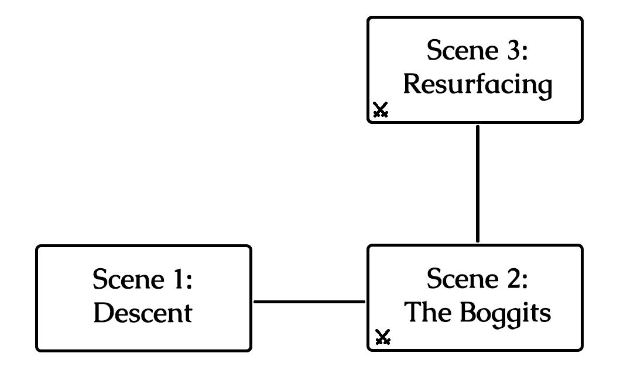
The scenes and how they connect in the quest.

Scene 1: Find the Ruins
The priest of Hammich is an odd fellow. By day, he oversees the church and the cemetery. By night, he practices magicks and scours ancient books for clues to some big mystery, a mystery he thinks he’s solved.
The first half of the job is simple enough: find and punish the thieves, burn or bury any corpses.
The second half is a bit strange: take the weird totem the priest has fashioned and put it in some kind of receptacle. He says you’ll know it when you see it and that it’ll help smoke the boggits out of their hole.
Boxed, italicized text like this is meant to be read aloud to your players!
Dir. Note: Director notes like this contain information the players should not be told!
Take a moment to do the following:
- Encourage the players to introduce their heroes if they haven’t already.
- Ask the players how their heroes each spend evenings in camp while on the road and which of their senses they most rely on while searching for goblins.
- Each of the heroes are each well-known in some region, if not this one. Ask each player how their hero has heard of one of the other heroes.
Every tree in Tallman Forest seems to hide an extra shadow. Every bird’s song sounds a little suspicious.
Suddenly, a scream from a bit further down the road interrupts your focus, and then hones it.
You were just a step to late! As you round the corner, you see the last goblin hit a victim over the head and haul their unconscious body into the forest away from their burning caravan.
Goblins are well known for their ambushes. No normal person would willingly follow a tribe through their home turf.

Following the goblin tribe through their forest is a recipe for disaster without taking extreme care. But if the party takes too much care, they won’t be quick enough to follow!
The heroes attempt a Medium Intuition Group Test to keep an eye out for goblin tricks and traps.
- Fewer than half succeed: The heroes are unable to detect and dodge every trap laid. The heroes begin their next combat encounter bleeding (save ends).
- Half or more succeed: The heroes are capable, through experience or instinct, to detect and evade every single goblin trap, whether hidden or obvious.
The heroes attempt a Hard Agility Group Test to follow the goblin tribe without them knowing, ideally coming upon their hideout without raising any alarms.
- Fewer than half succeed: The heroes falls for every goblin trick in the book, stumbling into pit traps, spikes, and falling bees nests, and the goblins notice! When the heroes arrive at the camp, the goblins are on guard and will not be surprised when the heroes initiate combat.
- Half or more succeed: The heroes deftly follow the goblins from just out of sight, without making a sound. They arrive at the goblin camp completely hidden and with the element of surprise!
The heroes earn 1 Victory if they succeed both group tests.

Scene 2: The Totem
The MacGraw goblins

Draw Steel! “The Totem”
The MacGraw goblins retreat into their cave and try to kill the hostages on the way.
Earn 1 Victory for keeping the enemies away from the activated totem for long enough for the height of the ruins to reach (# of heroes – 1) * 3.
- Standing trees are 2 squares tall and provide cover and concealment.
- Water squares instead swamp muck:

- Any hero can place the totem on the receptacle as a maneuver when they are adjacent the receptacle.
- While the totem is on the receptacle, it is activated. It cannot be deactivated. When the totem is activated, the ruins of Kingmire begin to rise from the swamp. The height of the ruins begins at zero.
- At the end of each hero’s turn, if there are no enemies within 5 squares of the totem, the height of the ruins increases by 1.

Encounter
The heroes begin in either the box marked “START.” The position of each enemy is immediately detectable.
The enemies have not yet noticed the heroes’ approach. Remind the heroes they have the element of surprise!

Party Size | Malice – Boggits  Enemy Forces:
2+ | Squad A: 6 Spinecleavers (m)
4+
* stuff

At the end of each round, the following enemies spawn from the edges of the map.

Party Size | Reinforcements:
2+ | Squad A: 6 Spinecleavers (m)
4+
* stuff

Events as the Ruins Rise
When a hero’s turn ends and the height of the ruins increases to (# of heroes – 1), water floods the map. Replace the map with TheTotem-Flooded. Any creature that is now in water and wasn’t before is pushed 3 squares diagonally northwest.

Scene 3: Ruins Resurfaced
The MacGraw goblins

Draw Steel! “Ruins Resurfaced”
The MacGraw goblins retreat into their cave and try to kill the hostages on the way.
Earn 1 Victory for killing all non-minions and destroying all the stolen corpses.
Dir. Note:
- Standing trees are 2 squares tall and provide cover and concealment.
- Water squares instead swamp muck:

Encounter
The heroes begin in either the box marked “START.” The position of each enemy is immediately detectable.

Party Size | Malice – Boggits  Enemy Forces:
2+ | Squad A: 6 Spinecleavers (m)
4+
* stuff

Example Draw Steel! “Blarg”
Blarg and his tribe make their final stand!
Earn 1 Victory for saving Silvester Fallwinter and freeing all hostages while they live.
Earn 1 Victory for defeating all the goblins and Blarg.

Encounter
Party Size | Malice – Goblins  Enemy Forces:
2+ | Squad A: 6 Snipers (m)  Squad B: 8 Spinecleavers (m)  Squad C: 1 Assassin + 1 Worg  Squad Blarg: 1 Blarg* + 1 Worg  Squadless: 2 Cursespitters
4+ | Squad D: 6 Spinecleavers (m) +  1 Warrior (capn)
* Blarg’s stat block is a Bugbear Roughneck with Stam. = 20 + (Party Size * 15).

Blarg’s First Turn
Blarg takes his turn only after the heroes have proven to be uncooperative. He uses his Throw maneuver to toss Silvester 5 squares up and over the water 4 squares below. Silvester takes falling damage (which is reduced by landing in sufficiently deep liquid), leaving him with 11 Stamina. Blarg directs the goblin snipers in Squad B to attack Silvester on their next turn.
Blarg continues his turn as normal. Note that Blarg is too large to ride his worg.

End of Round 1: Break the Dam!
At the end of the first round of combat, Blarg directs the goblins to open the dam. The squad nearest the dam moves up to their speed toward the three Levee dynamic terrain objects holding the water back. For the rest of the encounter, when a goblin ends their movement next to a Levee, they can destroy it. Once all three Levees are destroyed, immediately go to “Flood!”

Flood!
Once all three Levees are broken, the combat encounter changes significantly:
- Dir. Note: change the map from Cave to CaveFlooded and transfer all creature positions.
- Any creature who wasn’t in water but is in water on the new map is pushed 5 to the nearest wall or ledge.
- Remaining hostages in cages that are now in water cannot float above the surface and will die in 5 turns (including both hero and enemy turns). The heroes are made aware of this ticking clock; their hero-senses assure them of its accuracy.

Dir. Note: Tactics
Blarg can throw allies all over the place. Goblins generally like to hit enemies, then run away, especially up walls high enough that the heroes can’t reach them. The worg’s signature action has the Charge keyword, meaning it can move and use the ability together as its main action, and still have a leftover move action.

Blarg’s Hoard
The heroes can find among Blarg’s treasure hoard:
- 2 Healing Potions
- 3 pounds of seagrass (used to craft growth potions)
- 1 fur of a lightbender (used to craft iridescent armor)

What’s Next?
The heroes have completed their job for the Company of Cordwainers and can collect their reward back in Currens, provided they have proof that they killed the goblins and their leader. If Silvester lives, he can provide proof as a witness.
Another merchant in town might ask the heroes to escort him and his wares to Ivywatch further south…

falling damage = 2 * (vert push height + Blarg’s height above water – 4 from falling in liquid) = 2 * 5 = 10

